
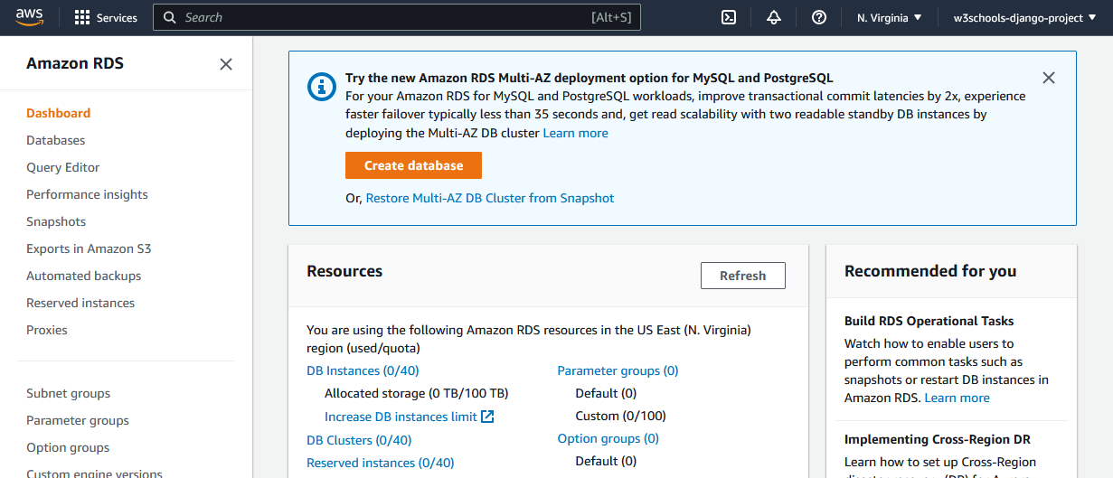

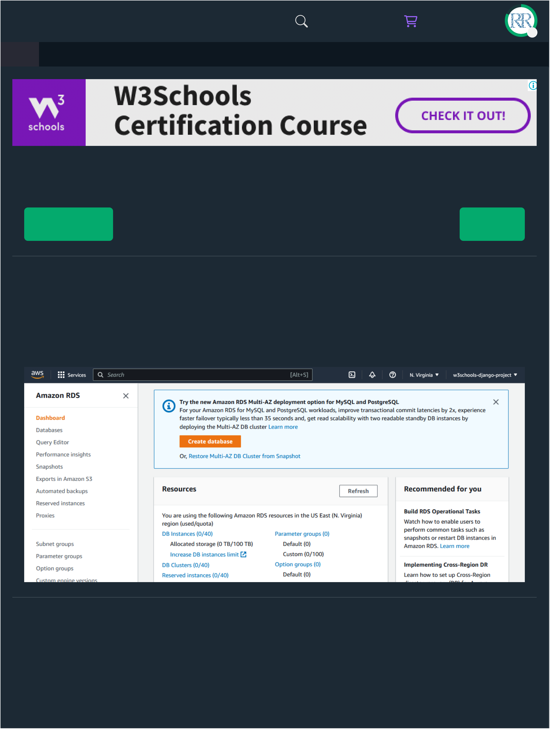
3/14/25, 1:43 AM |  |  |  |  | Django - Create PostgreSQL Database |  |  |  |  | C
HTML | CSS | JAVASCRIPT |  | SQL | PYTHON | JAVA | PHP | HOW TO | W3.CSS | C
Create PostgreSQL Database
Create Database
Inside the RDS service, create a database, either by navigating to the Database section, or just click the "Create database" button:
Settings
Once you have started creating a database, you will be given some choices for the type and settings of your database.
To add a PostgreSQL database to your Django project, choose the following options:
https://www.w3schools.com/django/django_db_create_rds.php 1/10

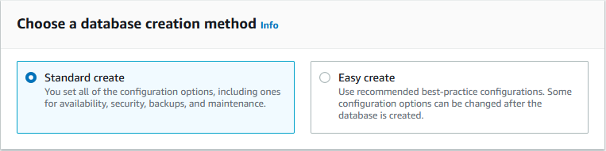
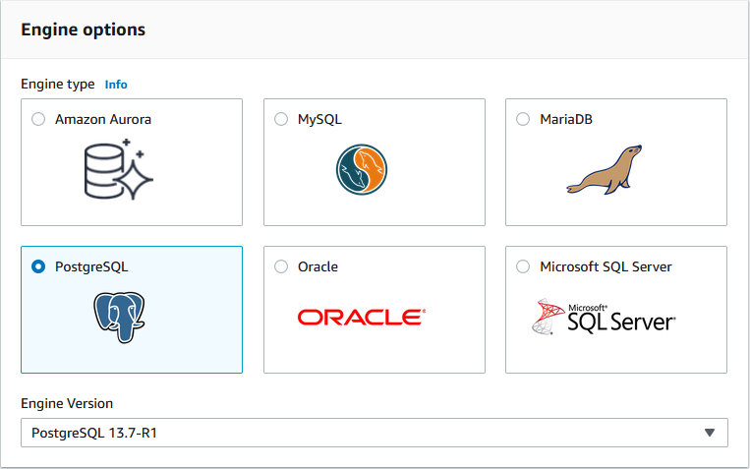
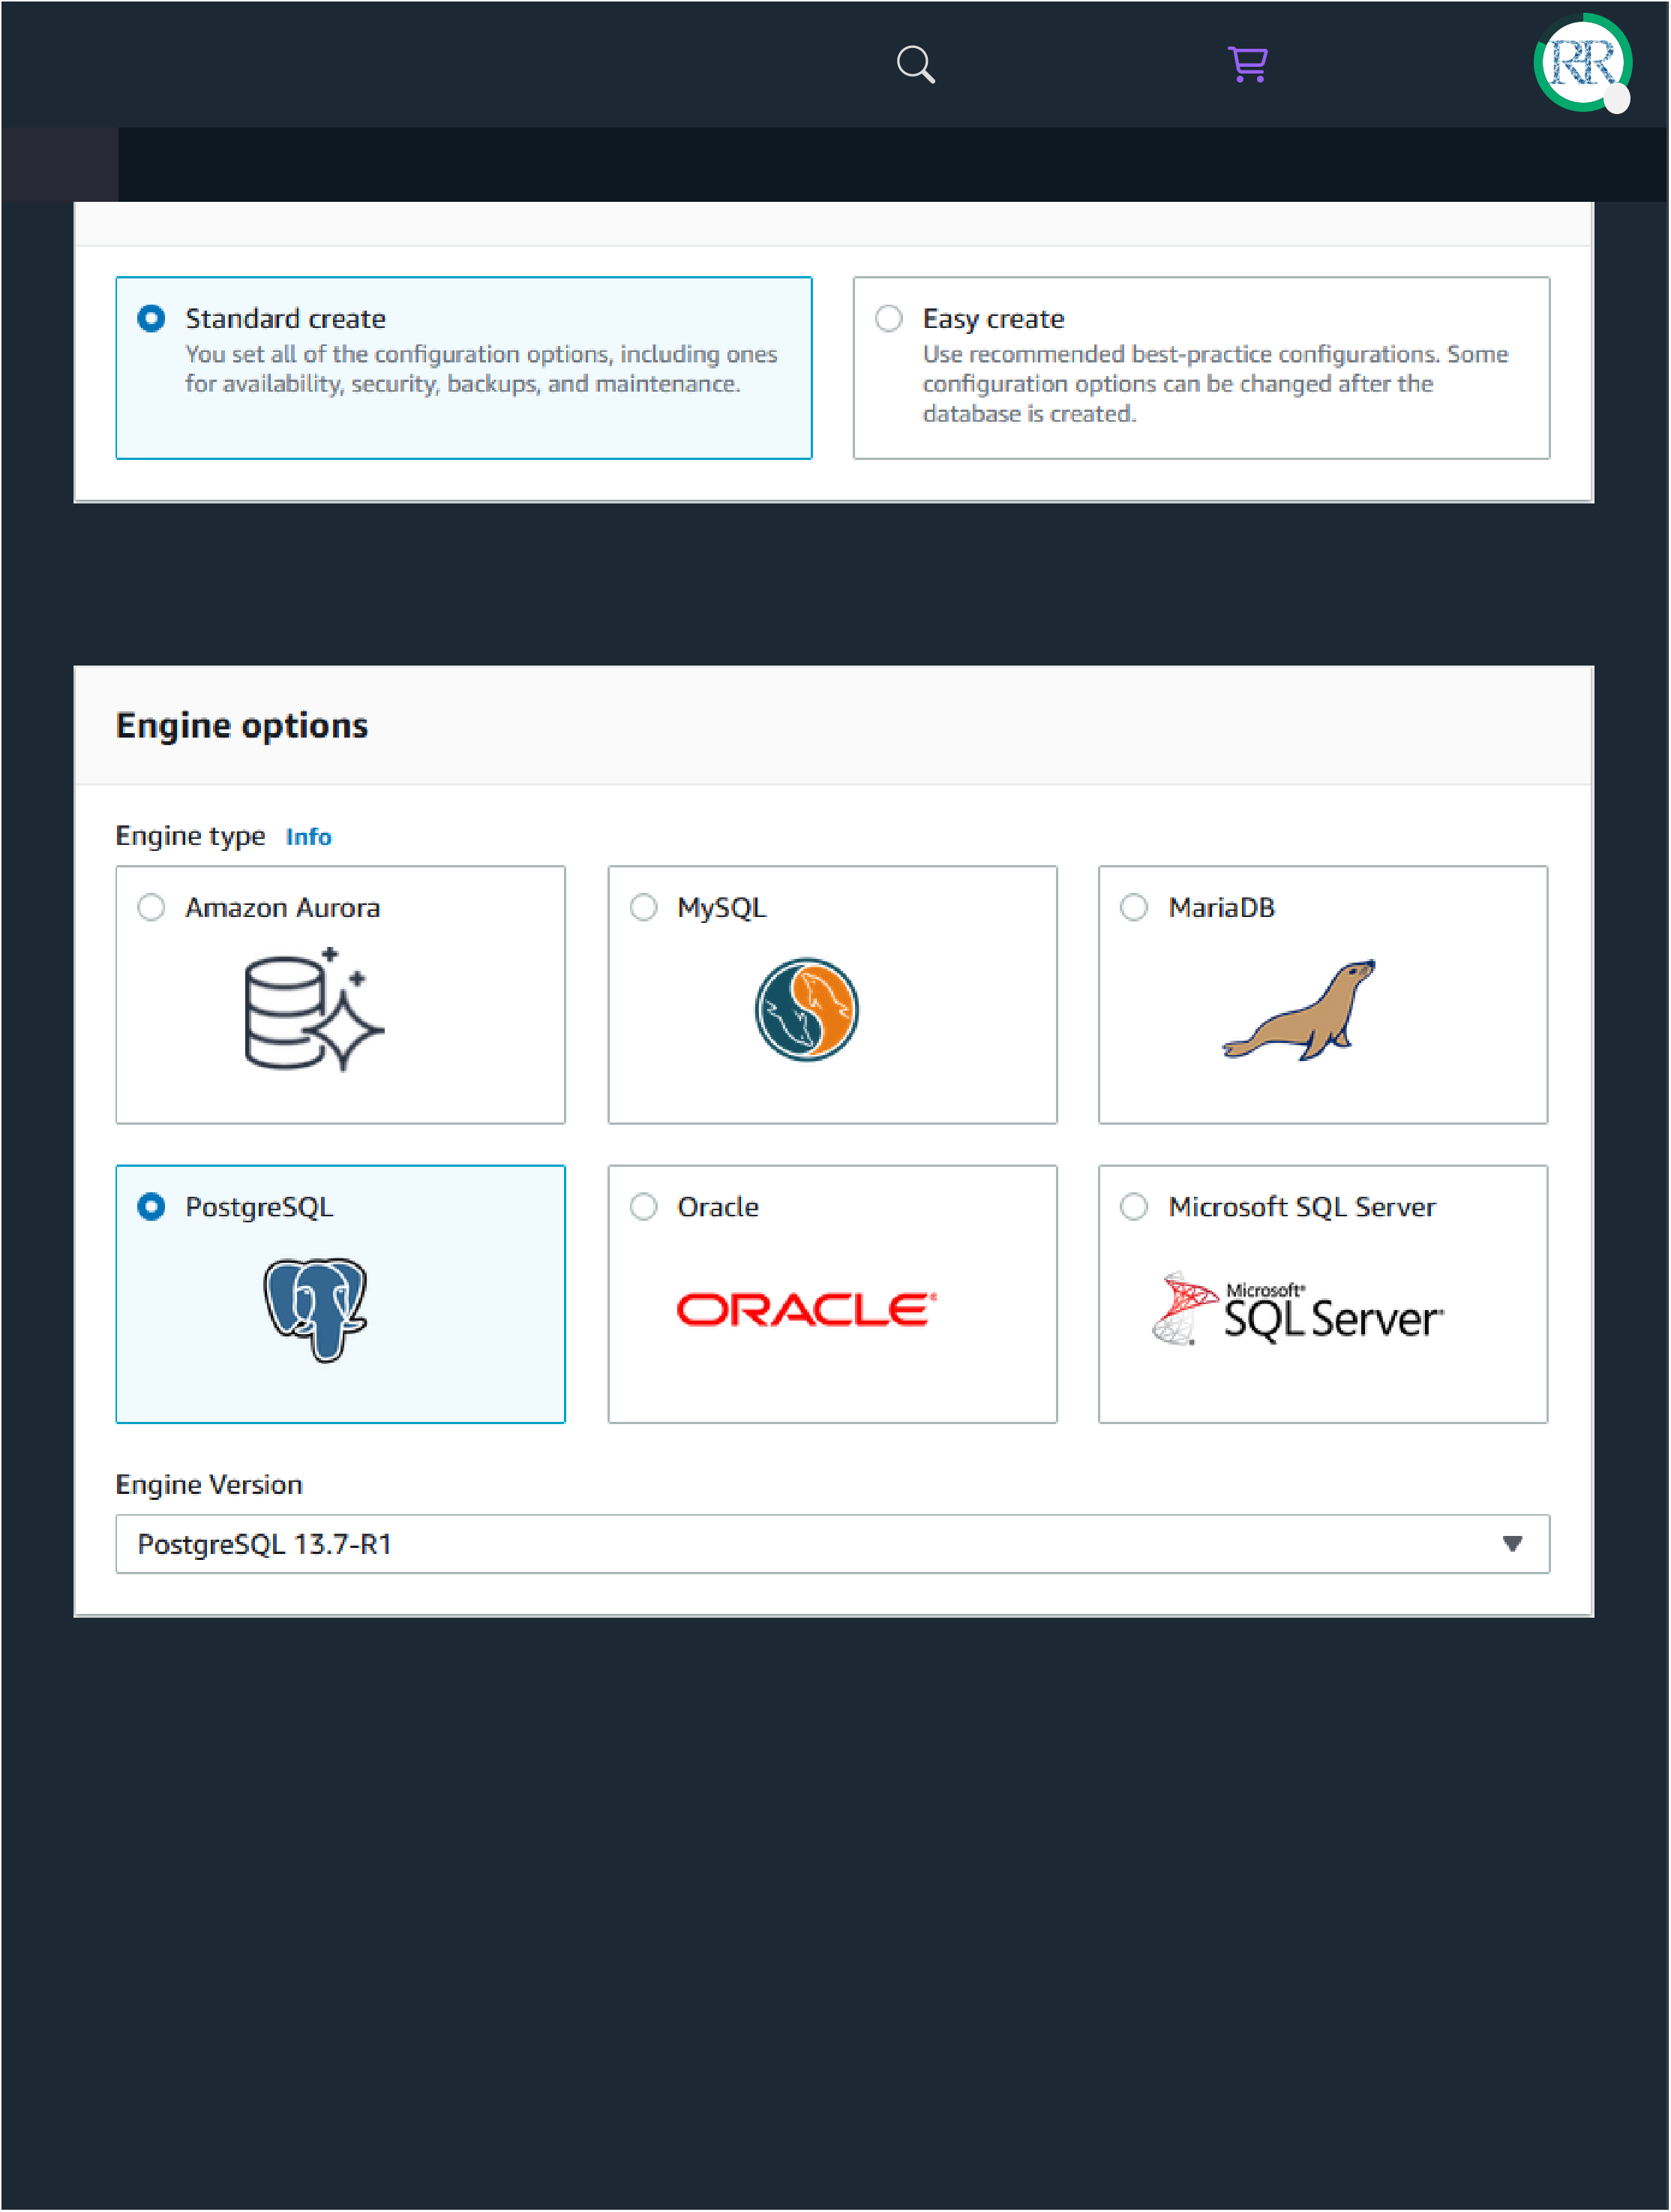
3/14/25, 1:43 AM | Django - Create PostgreSQL Database |  |  |  |  |  |  |  | C
Stan |  |  |  |  |  |  |  |  | C
HTML | CSS | JAVASCRIPT | SQL | PYTHON | JAVA | PHP | HOW TO | W3.CSS | C
PostgreSQL engine method:
Free Tier Template:
https://www.w3schools.com/django/django_db_create_rds.php 2/10

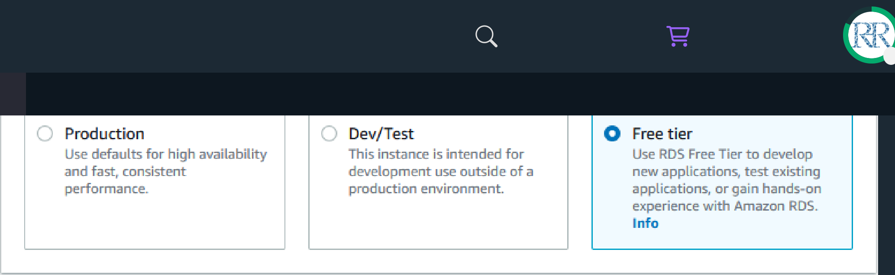
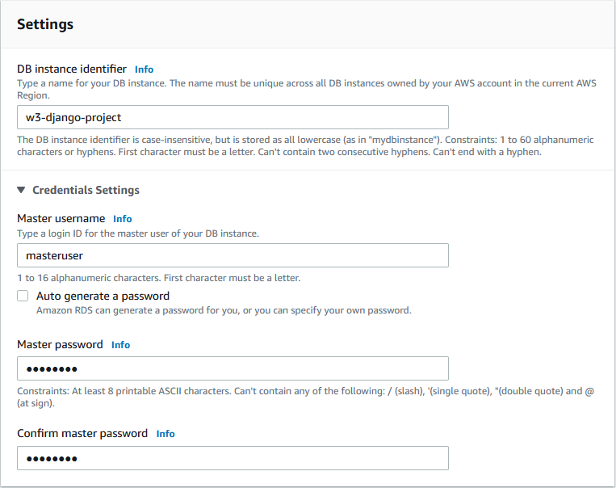
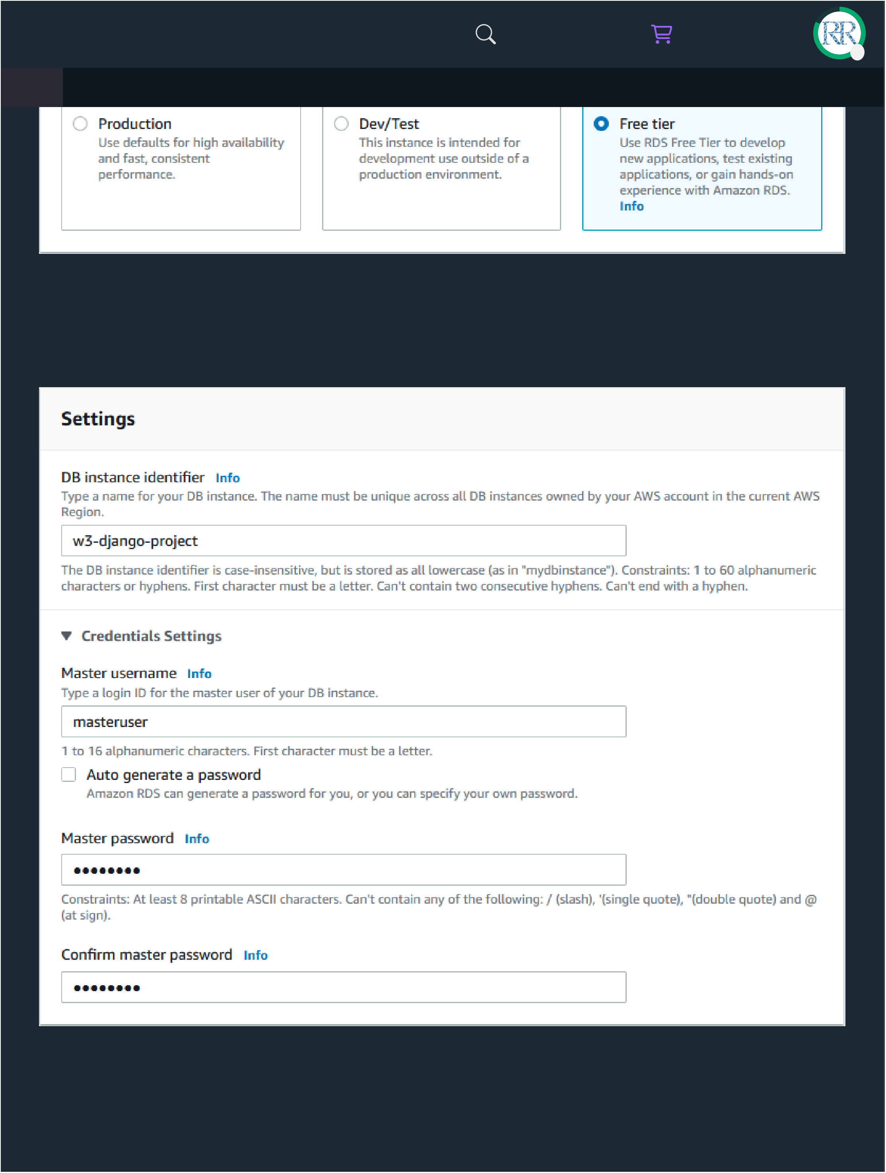
3/14/25, 1:43 AM |  |  |  |  | Django - Create PostgreSQL Database |  |  |  |  | C
HTML | CSS | JAVASCRIPT |  | SQL | PYTHON | JAVA | PHP | HOW TO | W3.CSS | C
Name of database, username, and password
You can choose any name, username, and password:
Keep the default instance configuration:
https://www.w3schools.com/django/django_db_create_rds.php 3/10

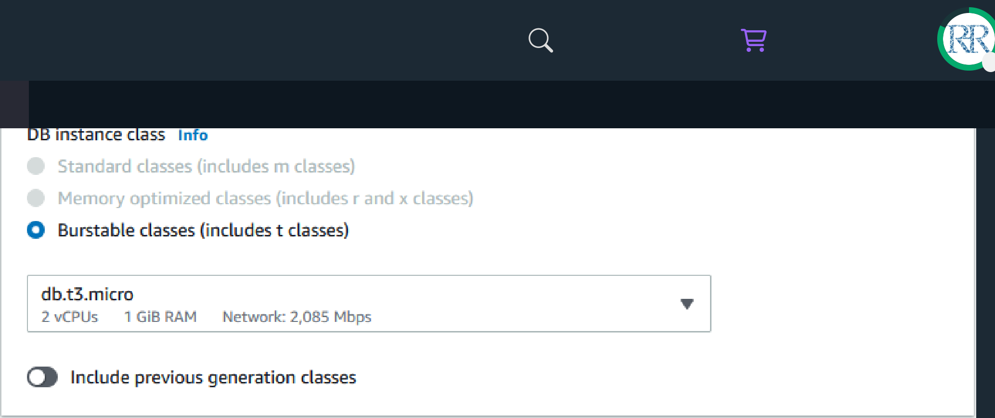
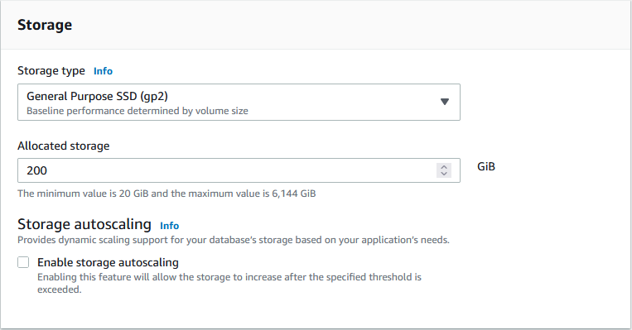
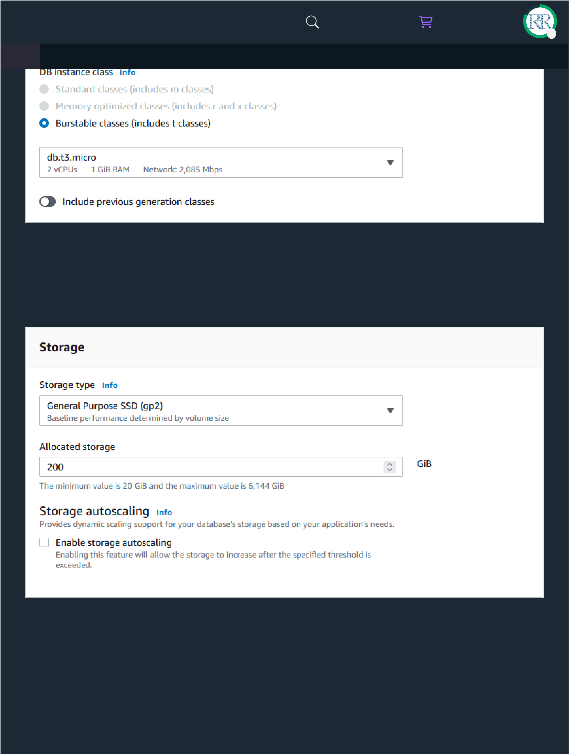
3/14/25, 1:43 AM |  |  |  |  | Django - Create PostgreSQL Database |  |  |  |  | C
HTML | CSS | JAVASCRIPT |  | SQL | PYTHON | JAVA | PHP | HOW TO | W3.CSS | C
Check off the storage autoscaling:
It can be a good thing to enable storage autoscaling, but for this tutorial it is not necessary.
Grant public access, and create a new security group: Give the security group a name, we will call it "w3-django":
https://www.w3schools.com/django/django_db_create_rds.php 4/10

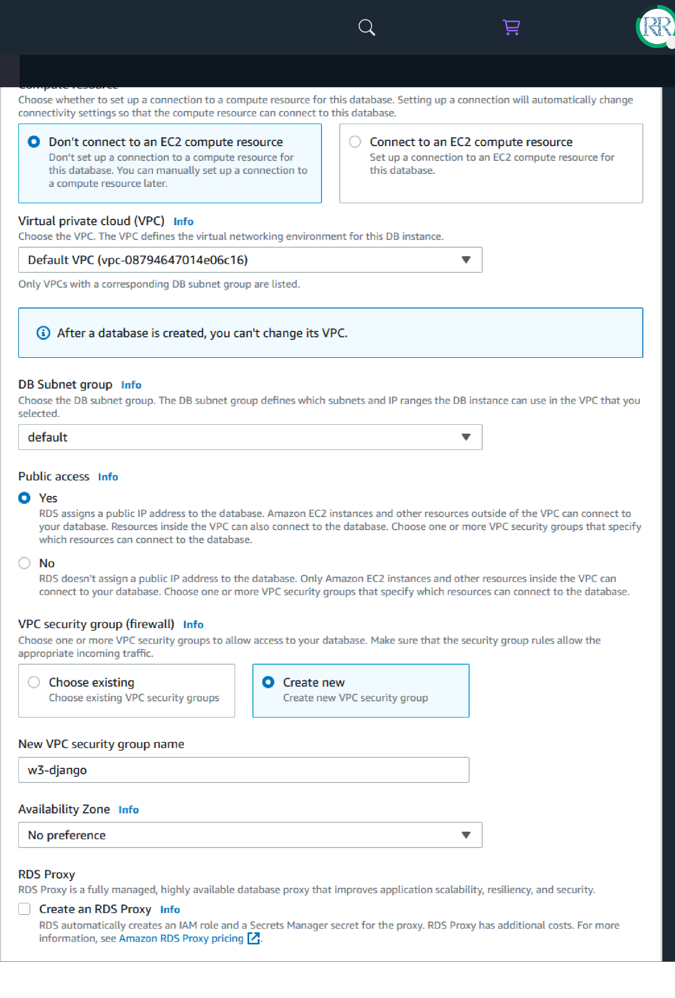
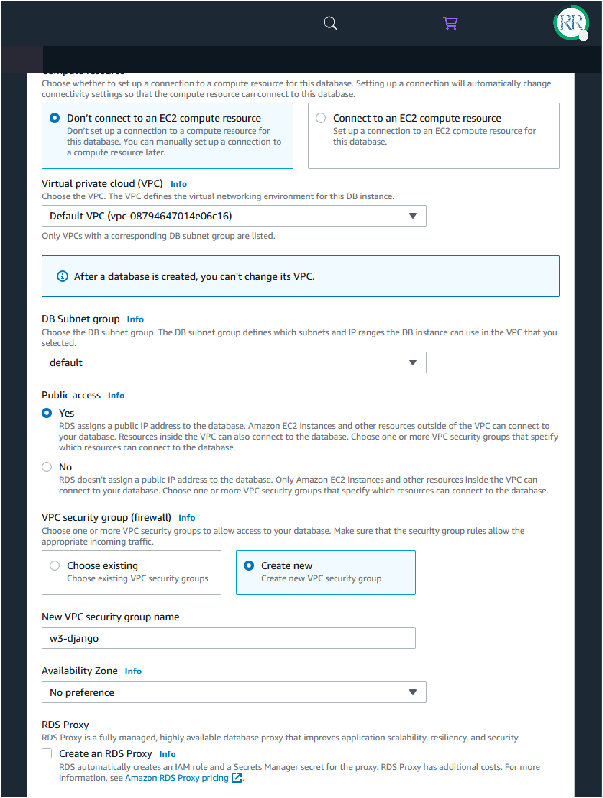
3/14/25, 1:43 AM |  |  |  |  | Django - Create PostgreSQL Database |  |  |  |  |  | 5/10
https://www.w3schools.com/django/django_db_create_rds.php


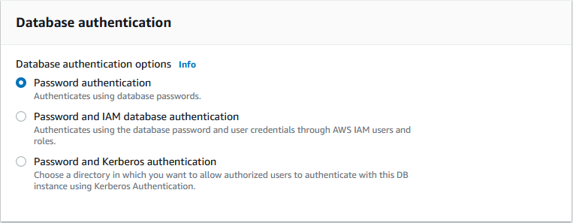
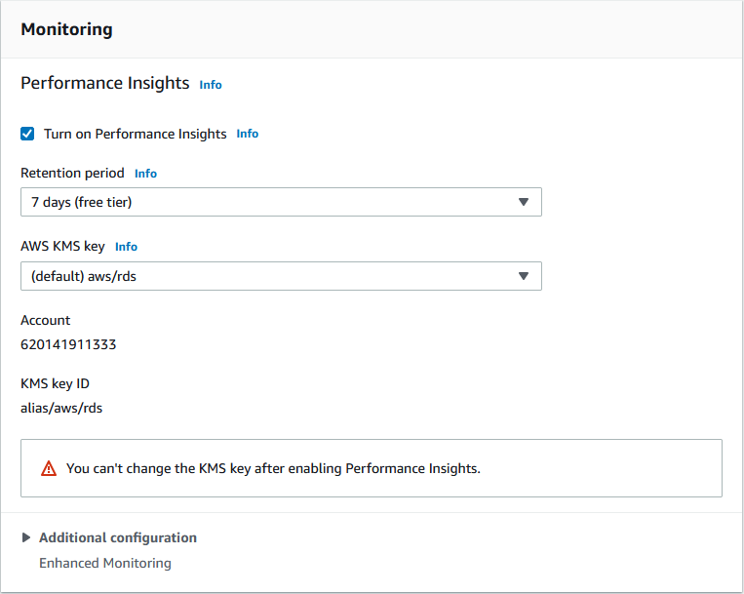
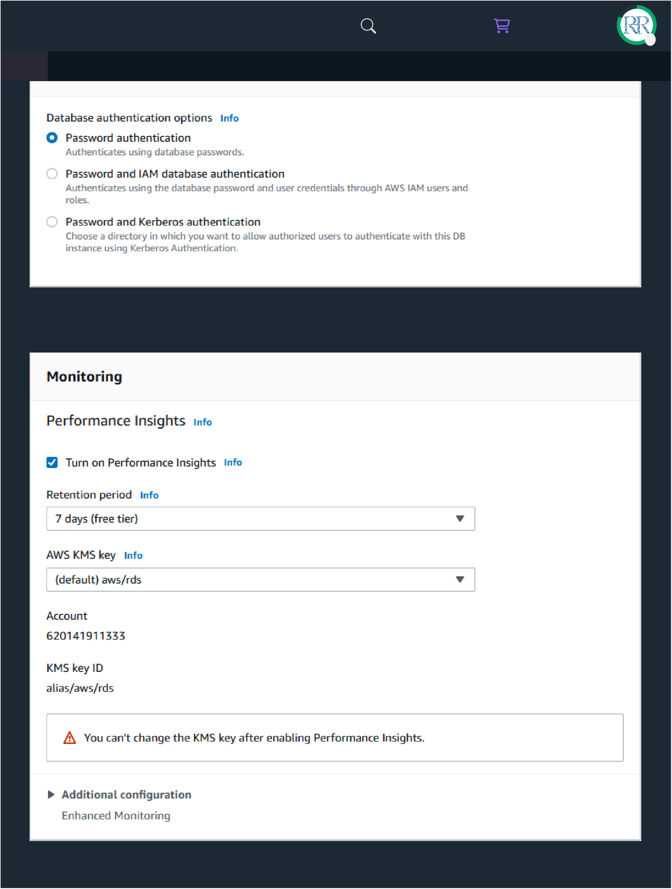
3/14/25, 1:43 AM | Django - Create PostgreSQL Database |  |  |  |  |  |  |  | C
HTML | CSS | JAVASCRIPT | SQL | PYTHON | JAVA | PHP | HOW TO | W3.CSS | C
Keep default monitoring:
https://www.w3schools.com/django/django_db_create_rds.php 6/10

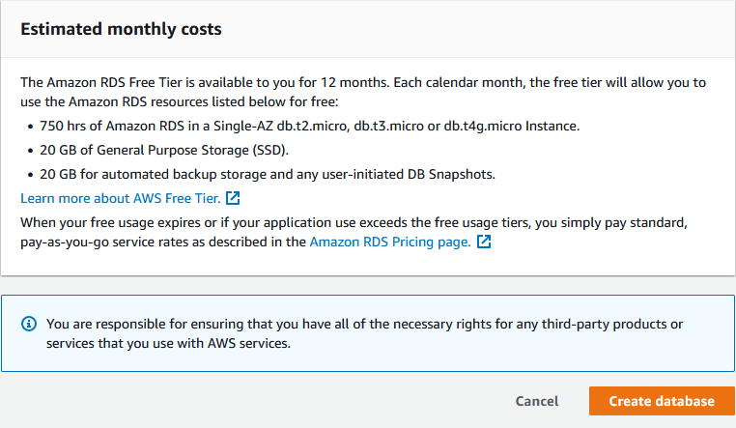
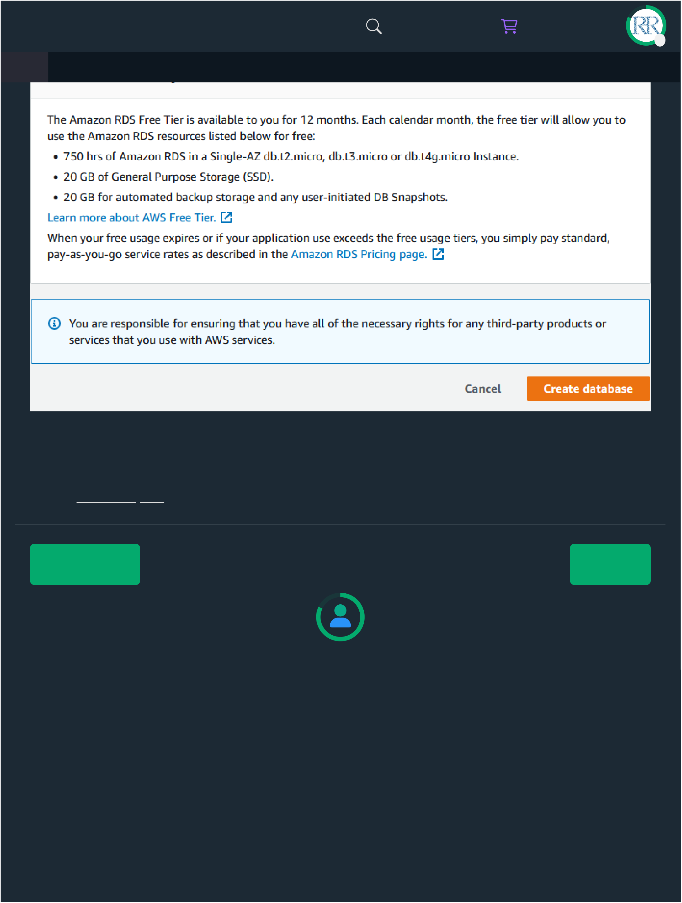
3/14/25, 1:43 AM |  |  |  | Django - Create PostgreSQL Database |  |  |  |  | C
HTML | CSS | JAVASCRIPT | SQL | PYTHON | JAVA | PHP | HOW TO | W3.CSS | C
This will take a few minutes, but when it is finished, you will have a new PostgreSQL
database, almost ready to run on your Django project!
In the you will learn how to connect your project to the database.
❮ Previous | Next ❯ | 7/10
https://www.w3schools.com/django/django_db_create_rds.php | Next ❯ | 7/10





3/14/25, 1:43 AM |  |  |  |  | Django - Create PostgreSQL Database |  |  |  |  |  | 8/10
https://www.w3schools.com/django/django_db_create_rds.php


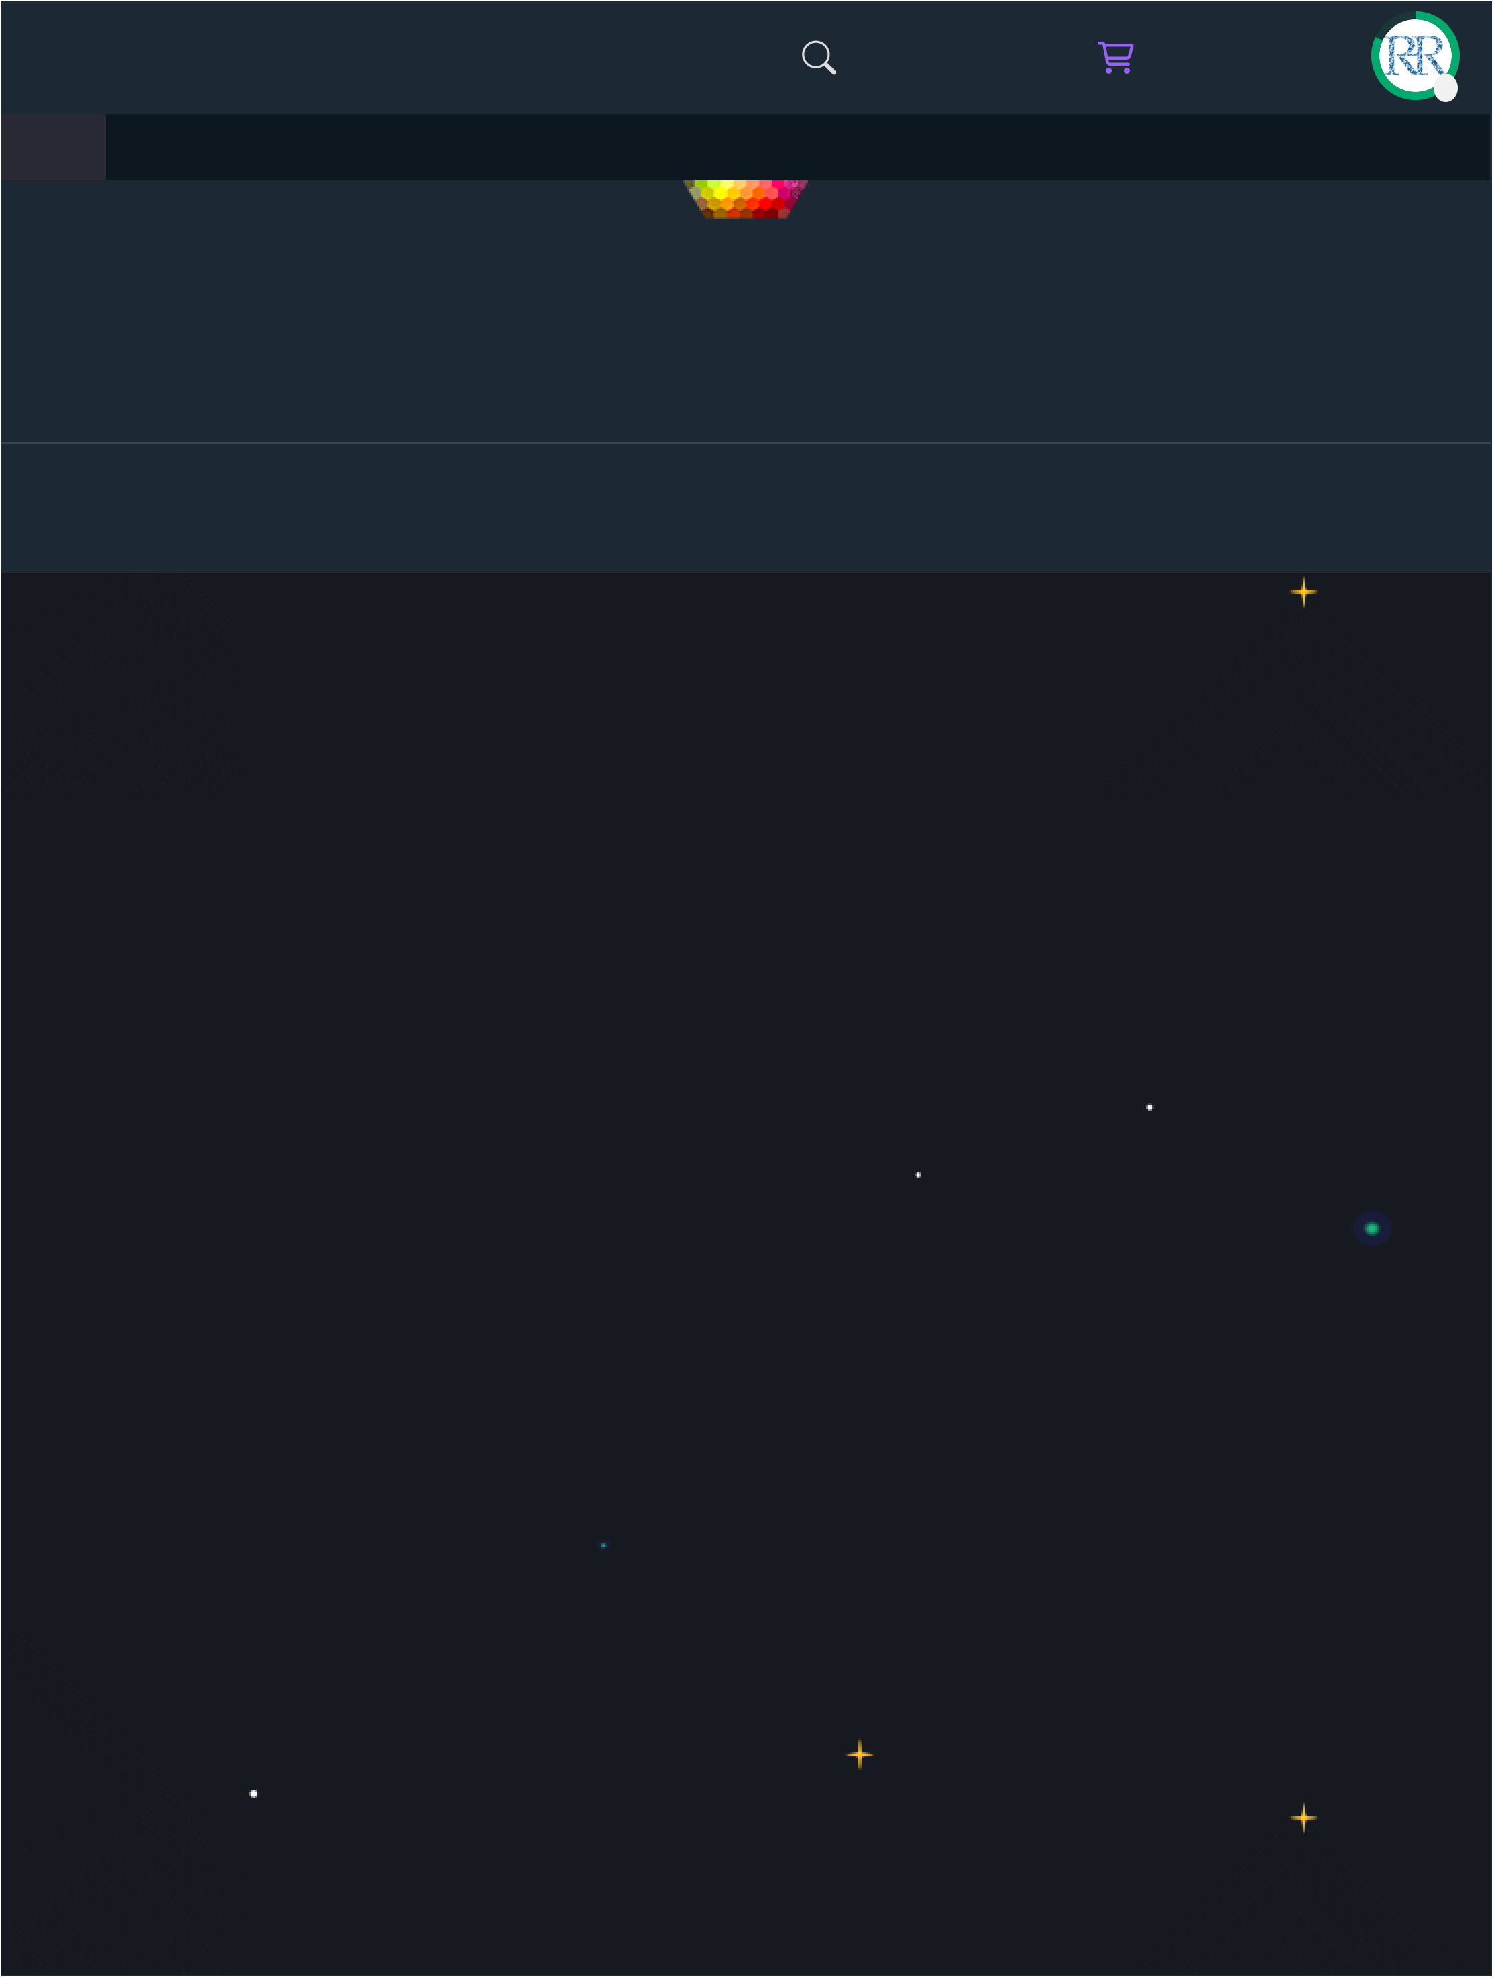
3/14/25, 1:43 AM |  |  |  |  | Django - Create PostgreSQL Database |  |  |  |  | C
HTML | CSS | JAVASCRIPT |  | SQL | P | JAVA | PHP | HOW TO | W3.CSS | C

Top Tutorials

Top References

https://www.w3schools.com/django/django_db_create_rds.php 9/10

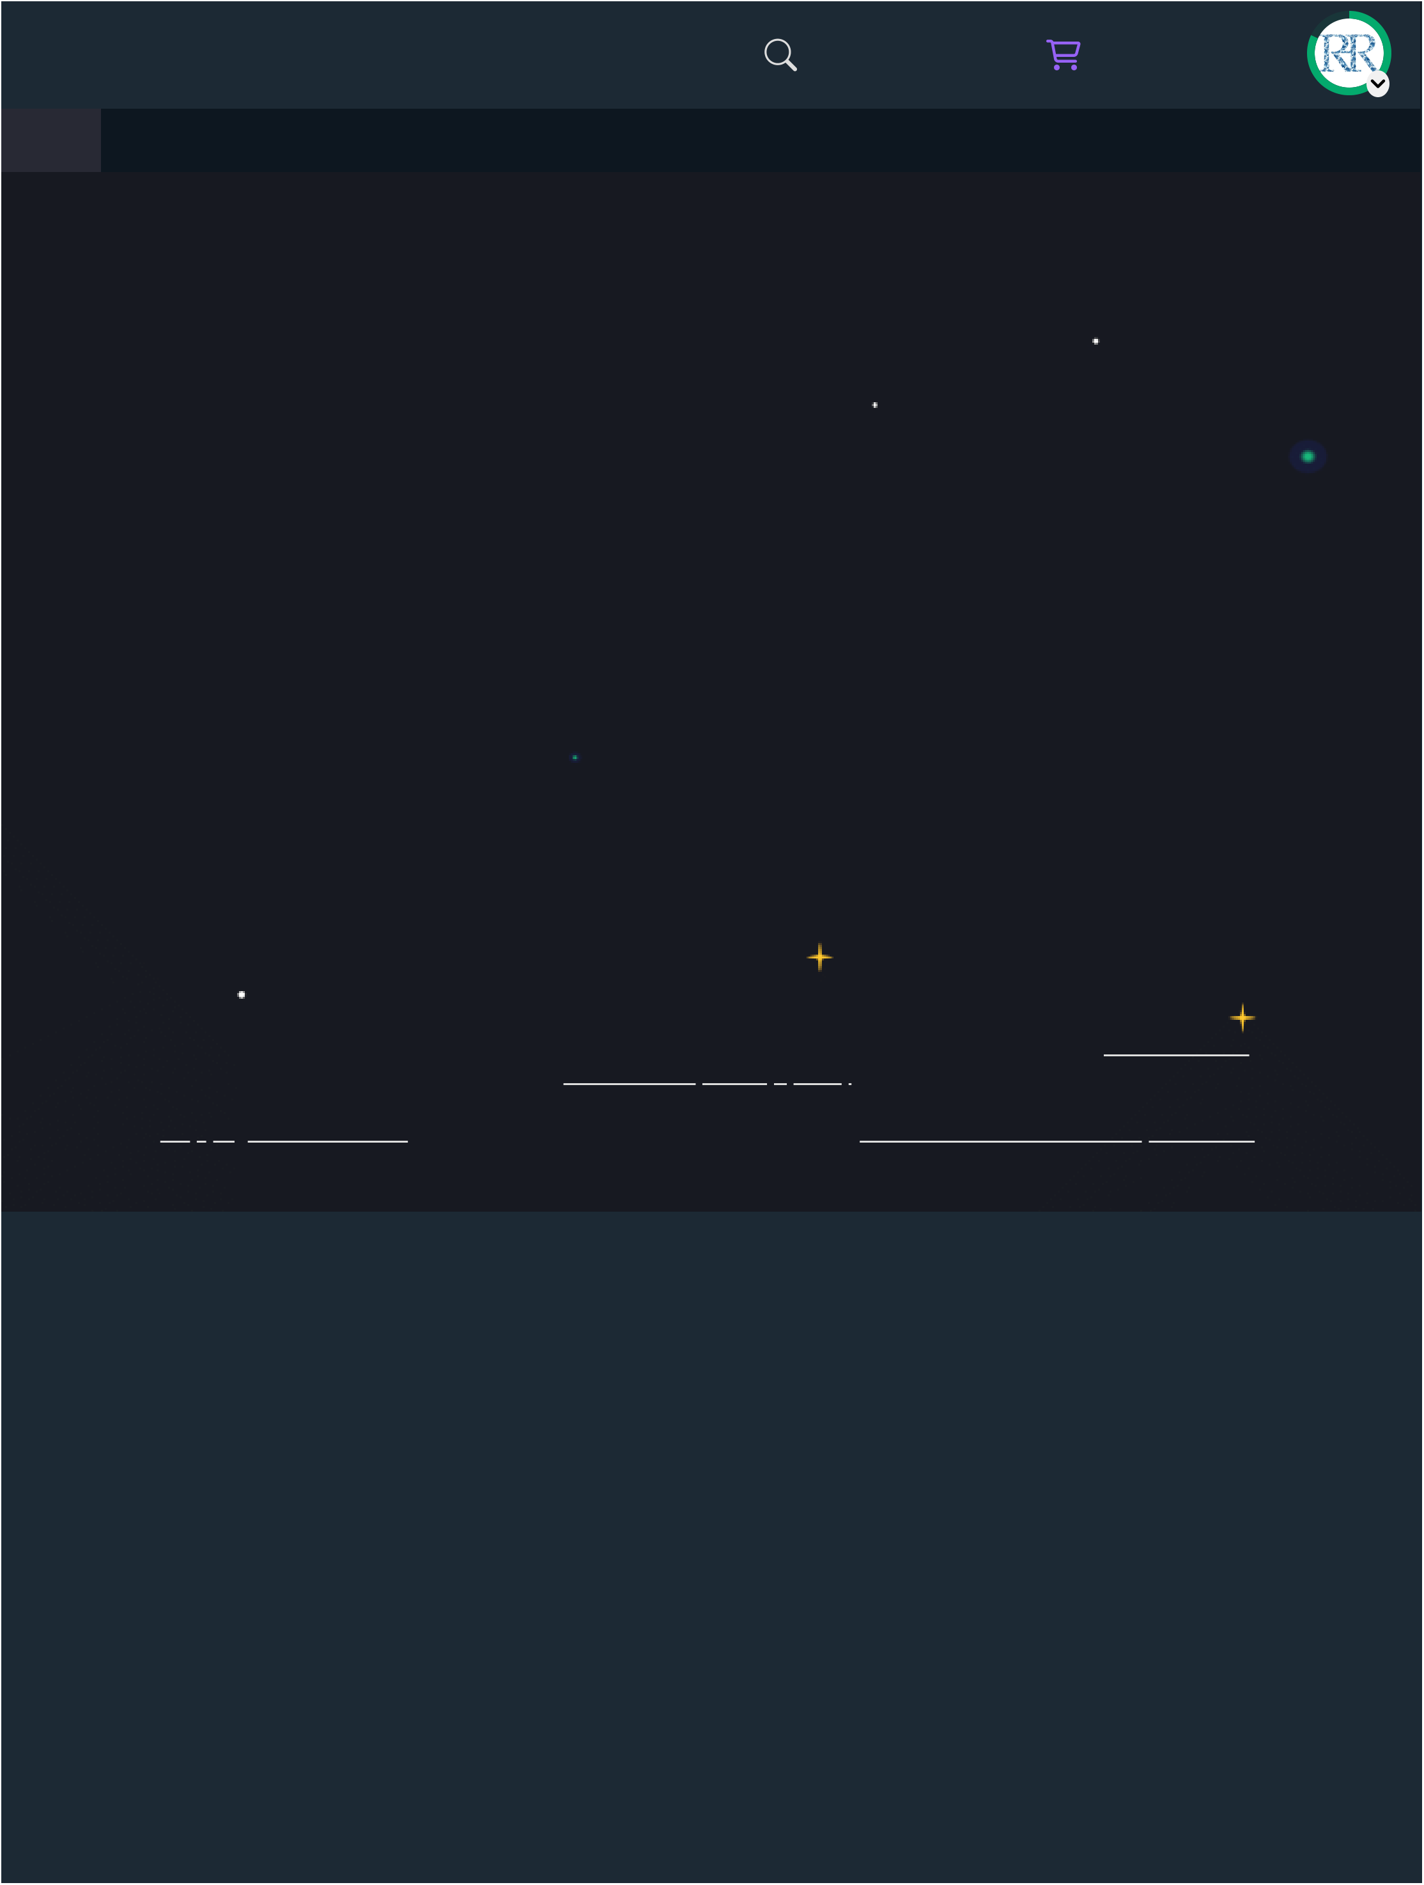
3/14/25, 1:43 AM | Django - Create PostgreSQL Database |  |  |  |  |  |  |  |  |  |  |  | C
 | Top Examples |  |  |  |  |  |  |  |  |  |  |  | C

W3Schools is optimized for learning and training. Examples might be simplified to improve reading and learning.
Tutorials, references, and examples are constantly reviewed to avoid errors, but we cannot warrant full correctness
of all content. While using W3Schools, you agree to have read and accepted our, .
by Refsnes Data. All Rights Reserved..
https://www.w3schools.com/django/django_db_create_rds.php 10/10

